Instructions for preparing a full paper for the
ECCOMAS Thematic Conference on Multibody Dynamics 2023

Name1 A. Surname1¹, Name2 B. Surname2², Name3 C. Surname3³, Name4 D. Surname4³

¹ Faculty of Mechanical Engineering  University of Technology  Address, Postcode City, Country  email1@address | ² Institute for Mechatronics  University of Technology  Address, Postcode City, Country  email2@address
³ Institute of Mechanics
University of Technology
Address, Postcode City, Country
[email3, email4]@address

ABSTRACT
The paper should be formatted according to the style guidelines presented in this template. The title of the paper should be typed in 14pt bold font and centered. Author names should be typed in 11pt bold font. In addition, the name of the presenting author should be underlined. Affiliations should be typed in general formatting style, centered within a corresponding bounding box. The reference marks can be omitted if all authors are from the same affiliation. The abstract part of the final paper should be formatted as one paragraph not longer than 250 words and it should fit to the title page. The abstract begins with the ''ABSTRACT'' header typed in bold 11pt. A maximum of 5 keywords have to be added after the abstract.
Keywords: Keyword 1, Keyword 2, Keyword 3, Keyword 4, Keyword 5.

- INTRODUCTION
All text should be written in Times New Roman font. General text should be justified and divided into logical paragraphs separated by 6pt spaces. All section headers except abstract and references header should be numbered using Arabic numbers. The headers are separated from the last preceding paragraph by 18pt space and the following text by 6pt space. Section headers should be typed in bold capital characters.
Subsections should be numbered using multilevel numbering. A maximum of two sublevels is allowed. The subsection headers are separated from the last preceding paragraph by 12pt space and the following text by 6pt space, they should be typed in bold characters. A font size of 11pt should be used if not specified otherwise.
- GENERAL INSTRUCTIONS
The paper must be written in English. The total length of the paper may not exceed 10 pages. The template margins must be followed. The paper used should have the size 210 x 297 mm, which is the European A4 size. It is suggested to use styles for formatting, automatic reference and figure numbering to avoid editorial errors. To avoid compatibility problems it is advised to use only the Latin alphabet and underscore character in the file name.

Equations
Equations must be numbered consecutively using right flushed Arabic numbers in brackets as shown in Equations (1) and (2).
, (1)
. (2)
All symbols of the equation should be explained. Matrices and vectors are upright boldface, scalars are normal italic, non-mathematical characters, such as indexes, are upright normal. Please use dot or comma.
Figures and tables
Figures and graphs are included using the same style as shown in Fig. 1. The contents of the Figure should be explained in its caption.
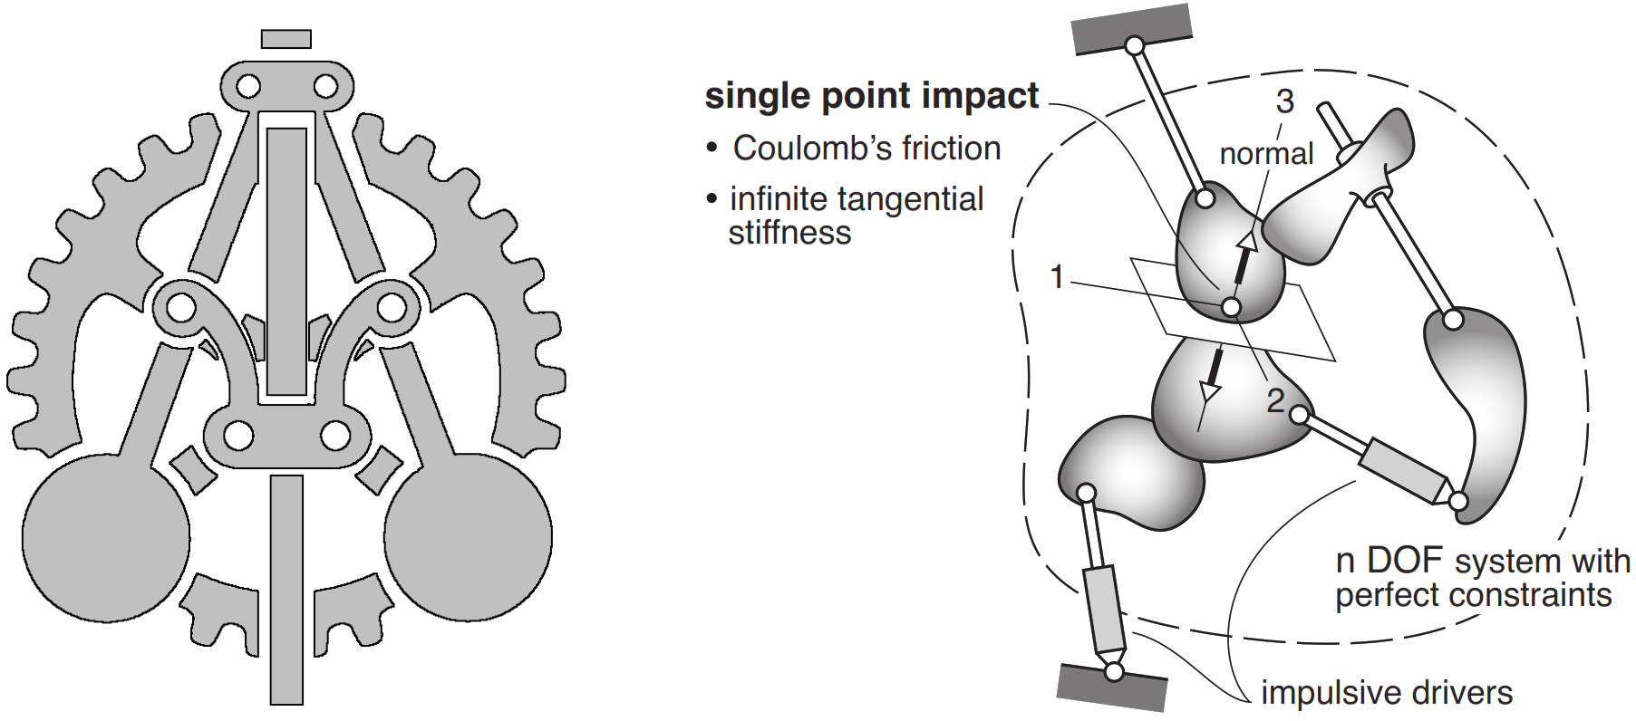
Figure 1. An example of a PNG figure (left panel) and an EPS figure (right panel) and the figure caption. PDF figure can be used similarly.
A resolution of 300dpi for pictures and 600dpi for line art is suggested, 1px wide lines in figures should be avoided as they may become invisible in print. There is no limit on the amount of figures as long as the total length of the paper is within the specified limit. Figures should be centered on the page. Font size in the figures should be similar to the main text font size.
Tables should be included using the same style as shown in Table 1. The contents of the table should be explained in its header. Tables should be centered.
Table 1. Example of a table and its header
T11 | T12 | T13 | T14
T21 | T22 | T23 | T24
References
Number citations consecutively in square brackets. Type the reference list in a separate bib file. The book citation example is [1], while [2], [3] are article in journals and [4] is an article in a conference proceedings. Numbering is based on the order of appearance in the text.
- SUBMISSION OF THE FULL PAPER
Authors are optionally requested to submit the full paper of a maximum of 10 pages no later than March 29, 2023. The uploaded file must be in PDF format. When creating the PDF, please make sure to use A4 as paper size. Before submitting your paper, check that it is according to the conference style guidelines presented in this template.

- CONCLUSIONS
See you in Lisbon!
ACKNOWLEDGMENTS
The Acknowledgments heading should be treated as a section heading with no number assigned to it.
REFERENCES
de Jalón, J.G., Bayo, E.: Kinematic and dynamic simulation of multibody systems: the realtime challenge. Springer-Verlag, New York, NY (1994) ISBN:3-540-94096-0.
Denavit, J., Hartenberg, R.S.: A kinematic notation for lower-pair mechanisms based on matrices. Trans ASME J. Appl. Mech. 23 (1955) 215–221
Baumgarte, J.: Stabilization of constraints and integrals of motion in dynamical systems. Computer Methods in Applied Mechanics and Engineering 1 (1972) 1–16 doi:10.1016/00457825(72)90018-7.
Baillieul, J.: Kinematic programming alternatives for redundant manipulators. In: IEEE International Conference on Robotics and Automation, St. Louis, MO, USA (1985) 722–728 doi:10.1109/ROBOT.1985.1087234.

